**ELECTRIC POTENTIAL, POTENTIAL DIFFERENCE AND ELECTROMOTIVE FORCE:**

**Electric potential.**

* The word ***potential*** refers to the ability to perform work.
* If work has to be done to move charge from one point to another, the points are said to be at different ***potential***.

The *earth potential is taken to be zero*. The potential of any given point is equal to the work done to move a small positive charge from earth up to that point.

In symbols:

**S.I unit of Electric potential:**

Electric potential is measured in ***volts*** (**V**).

NOTE : A volt is the work done in moving 1 coulomb of charge from one point to another.

**DEFINITION:**

***The potential in volts at any point is the work done per coulomb in bringing positive charge from earth to that point.***

**POSITIVE AND NEGATIVE POTENTIAL:**

* In the figure below, work must be done to move positive charge from earth to conductor A.

Conductor A is at a ***higher***potential than the earth, and its potential is taken as ***positive***.

* On the other hand, work must be done to move a positive charge from point B to earth.

B is at a***lowe****r* potential than the earth, therefore its potential is ***negative***.

B

Zero potential

Positive potential

Negative potential

0 V

+10 V

-10 V

**Potential difference and electron flow:**

* If two conductors are at different potential, there is a **potential difference**, or **p.d** between them.
* ***Electrons always flow from lower to higher potential.*** i.e towards the more positive potential.
* ***Electric current flows in the direction opposite to that of electron flow.***

**Definition:**

**The potential difference between two points in an electric field or circuit is the work done in moving one coulomb of charge from one point to the other.**

**ELECTROMOTIVE FORCE ( e.m.f)**

The potential difference between the terminals of a cell indicates the energy provided to each coulomb of charge in the circuit e.g. a cell labelled 1.5 V gives 1.5 joules of potential difference to each coulomb of charge in the circuit. This energy is then converted to other forms energy e.g light and heat in the lamp.

Therefore:

1. The e.m.f of a cell is the potential difference across the terminals of a cell in an open circuit.
2. The. e.m.f of a cell is the total energy per coulomb of charge available from the cell.
3. The e.m.f of a cell is the total potential difference across all external devices to which the cell is supplying current in the circuit including the p.d required to drive current through the cell itself.

S

R

V

**N.B.**

* The p.d across the terminals of the cell when the switch S is open is called ***electromotive force (e.m.f),E*** of the cell.
* The p.d across the terminals of the cell when switch S is closed is called ***terminal p.d, V***
* The difference between E and V i.e is the p.d required to drive current through the cell itself in a closed circuit.

**SOURCES OF ELECTRMOTIVE FORCE - ELECTRIC CELLS**

*Electric cells are devices that can produce electricity by chemical action*.

***An electric cell is a device that converts chemical energy to electrical energy***.

**Types of Cells:**

There are two types of cells, namely

1. Primary cells
2. Secondary cells.

**Primary cells:**

A ***primary cell*** is *a cell that produces current as a result of an irreversible chemical reaction* i.e. can not be recharged when it runs down.

**Examples of Primary Cells**

1. Simple cells
2. Dry cells
3. Leclanch’e wet cell.

**Secondary cells:**

*A* ***secondary cell*** *is cell that produces electric current as a result of reversible chemical reaction.*

A secondary cell can be recharged when it runs down, by passing current backwards through it.

**Examples of Secondary Cells**

1. Lead acid accumulators
2. Alkaline cells (Nickel iron cells)

**Differences between primary and secondary cells.**

|  |  |
| --- | --- |
| **Secondary cell** | **Primary cell** |
| * Current is produced as a result of reversible chemical reaction. | * Current is produced as a result of irreversible chemical reactions. |
| * Can be recharged when it runs down. | * Cannot be recharged when it runs down. |

**Simple cells**

A simple cell is made up of electrodes i.e. a copper rod(positive electrode) and a Zinc rod(negative electrode) that are dipped into an electrolyte (dilute sulphuric acid) and are connected by a piece of conducting wire . The more reactive metal in the reactivity series i.e. Zinc, forms the cathode while copper forms the Anode. The electrolyte being dilute sulphuric acid ionizes as below.

(aq) → 2(aq) + SO42-(aq)

**A Simple cell**

**How a simple cell works:**

The zinc plate slowly dissolves and goes into the solution as zinc ions which displace hydrogen ions to form zinc sulphate.

Zn(s) → Zn2+(aq) + 2e-

Zn2+(aq) + SO42- (aq) →ZnSO4 (aq)

The displaced hydrogen ions move to the copper plate. The electrons from the zinc travel through the external circuit and arrive at the copper electrode where they combine with the hydrogen ions to form hydrogen gas.

2H+(aq) + 2e- → H2(g)

This flow of electrons from the cathode to anode causes the flow of electricity from the anode to the cathode causing the galvanometer to deflect.

**Defects of a simple cell.**

A simple cell is found to work for a short time after which the current stops flowing because of two major defects, namely;

1. Polarization.
2. Local action.
3. **Polarization**

This is the collection of hydrogen bubbles at the anode which partially insulate it from the electrolyte. This slows down and eventually stops the working of the cell.

**Prevention/ reduction of polarization**.

This can be reduced by;

1. Occasional brushing of the anode.
2. Adding a depolarizer e.g. potassium dichromate ( K2Cr2O┐) which oxidizes hydrogen.
3. **Local action**

This is the gradual wearing down of the zinc electrode (cathode) as a result of impurities on the plate reacting with the acid to form hydrogen bubbles.

**Prevention of local action**

The zinc plate is cleaned in concentrated sulphuric acid and then rubbed with mercury. The mercury zinc amalgam covers up the impurities thereby preventing their contact with the acid electrolyte.

**DRY CELLS**

* . It uses wet paste of Ammonium Chloride as the electrolyte.
* The anode is the ***carbon rod*** surrounded by a mixture of powered carbon and manganese dioxide placed in the centre of the ***Zinc container*** which forms the cathode.



**Action of a dry cell.**

The source of energy is chemical action between Zinc and ammonium chloride jelly. As a result, hydrogen gas is produced which collects at the carbon rod and polarizes the cell.

The manganese (iv) oxide oxidizes the hydrogen to water in the cell and enables it to supply current for some time.

**NB :** ***Local action*** cannot be completely stopped in dry cells and therefore the cell deteriorates with time.

***The dry cell can produce an e.m.f. of about 1.5 V.***

**Advantages of a dry cell over simple cells**

* It is portable.
* Its electrolyte is in jelly form and cannot pour easily.

Dry cells are commonly used in torches, remote control gadgets, transistor radios, wall-clocks, e.t.c.

**The Leclanche Wet cell:**

The leclanche wet cell is identical to the dry cell except that its electrolyte ***is liquid - Ammonium chloride solution***

* Its positive pole is a ***carbon plate*** surrounded by a depolarizing mixture of powdered carbon and manganese (iv) oxide in a porous pot.
* A ***zinc rod*** acts as its negative pole.
* Both the porous pot with its contents and the zinc rod are placed inside a glass jar containing a solution of ammonium chloride.

**Limitations of the of the leclanche wet cell**

1. The depolarizing action is very slow; therefore, the cell is unsuitable for maintaining a steady current for a long period.

**Maintenance of the Wet cell.**

* Water is occasionally added to make up for losses due to evaporation.

**SECONDARY CELLS**

1. **Lead acid accumulators.**

It consists of lead oxide as a positive electrode and lead as the negative electrode. The electrolyte is the dilute sulphuric acid.

The lead acid accumulator supplies much larger currents than the dry cell. It consists of six accumulators in series. During discharge, both electrodes change to lead sulphate and the acid becomes more dilute.

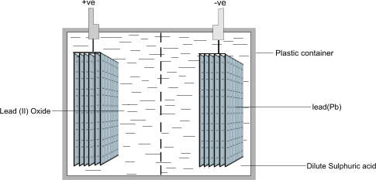

When fully charged, the relative density of the acid is 1.25 which falls to 1.18 at cell discharge.

***Care and maintenance of lead acid accumulators***.

The lead acid accumulator can be used for a long time provided the following are taken:

* The liquid level must be maintained using distilled water. This ensures that the electrodes are not exposed.
* The cell should be charged if the relative density of the electrolyte falls below 1.125.
* The battery should be kept clean so that the current does not leak away across the casing to the terminals.
* The positive terminal should not be connected directly to the negative terminal. When this is done (short circuit), too much current is taken from the cell. This tends to destroy it.
* The battery should be charged regularly and should not be left in uncharged condition for a long time. The effect of the charging current is to change lead sulphate on both positive and negative plate into lead (ii) oxide and to return the sulphate into the electrolytes.

**The Nickel- Cadmium Alkaline Cells or Nife Accumulators.**

This is called so because the electrolyte is an alkaline such as potassium hydroxide dissolved in water. The positive electrode is ***Nickel hydroxide*** and the negative is ***iron or Candium***.

***Advantages of the alkaline accumulator over lead acid accumulator***.

* They are not affected by over-charging and over-discharging.
* They deliver large amounts of current.
* They can be left in a discharged condition without harm.
* They require very little attention to maintain.
* They longer life time than lead accumulators.

***Advantages of lead-acid accumulators over alkaline accumulators***.

* They are more efficient than alkaline accumulators.
* They have relatively larger e.m.f. than alkaline- accumulators.
* Their e.m.f is more steady compared to that of alkaline accumulators when discharging.
* They have a lower internal resistance compared to alkaline accumulators.

**Charging an accumulator.**

A charging circuit is seen in the diagram below;

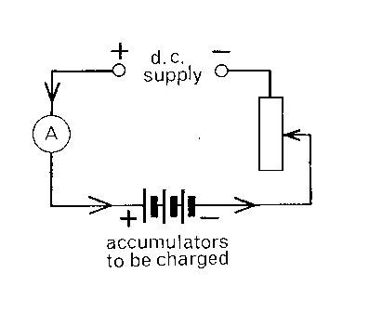

* The supply must be d.c (direct current) of greater E.M.F than that of the accumulator.
* The positive terminal of the supply is connected to the positive terminal of the accumulator and the current is adjusted to a recommended value.
* Before charging, the accumulators must be topped up with distilled water.

**NOTE: When charging an accumulator:**

1. Charging should be carried out slowly with a small charging current that will not destroy the paste in the grids.
2. When the accumulator is fully charged, hydrogen is evolved from the spongy lead grid and oxygen from the lead (IV) oxide grid. This is called ‘gassing’.

**CAPACITY OF AN ACCUMULATOR:**

*The* ***capacity of an accumulator*** *is the amount of energy which the accumulator can store.*

The capacity of a cell is measured in ***ampere- hours*** (Ah).

e.g. If a cell is labelled 3 Ah, it means that the cell can maintain a current of 3 A for 1 hour.

**Example:**

1. A battery has a capacity of 200 Ah.
2. How long will it take to run down if its discharging using a current of 0.8 A?
3. How long will it take to charge it using a current of 8 A?

ANSWER:

.

1. A cell phone has a battery labelled 20 mAh. In order to initialize it, it is recommended that it should be charged for at least 4 hours. Determine the current used o charge the phone.

ANSWER:

**OTHER sources of emf.**

These include:

1. Photo electric cells (Solar cells)
2. Thermo electric effect (thermo couples)
3. Piazo electric effect (crystal pickups)

**Photo electric cells:**

**PHOTO ELECTRIC EMISSION:**

This is the emission of electrons from a certain metal plate e.g zinc plate, when electromagnetic radiations of short-wave length fall on it.

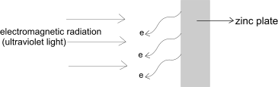

**THE PHOTOELECTRIC CELL**.

* The photoelectric cell uses photoelectric effect to convert light energy into electric energy.
* The strength of the current produced depends on the intensity of the incident light radiation on the metal.

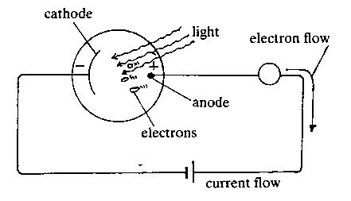

Evacuated transparent tube

* When a suitable radiation falls on the zinc cathode, it emits electrons by photoelectric emission.
* The anode attracts the electrons which then pass through an external circuit causing an electric current.

**N.B** If gas is introduced into the tube, the current decreases slowly because the gas particles collide with the electrons, hence reducing the number of electrons reaching the anode.

**APPLICATIONS OF PHOTOELECTRIC EFFECT:**

Photoelectric effect is applied in:

1. Burglar alarms.
2. Automatic lighting systems
3. In solar calculators.
4. Television cameras
5. Automatic door systems
6. Sound track on a film.

**THERMOELECTRIC EFFECT:**

**Thermocouple:**When two dissimilar metals are joined to form a junction and the junction is heated, an e.m.f is created.

When each of the free ends of the metal wires are connected to a sensitive galvanometer, a small current flows in the circuit.

G

heat

Platinum

Bismuth

The magnitude of the e.m.f. produced depends on

1. the temperature of the junction.
2. the pair of metals used.

e.m.f

temperature

Neutral temperature

***Neutral temperature*** *is the temperature of the hot junction at which the e.m.f is a maximum.*

Thermocouples are used as small power supply in space satellites, weather buoys and weather ships.

**Advantages of thermocouples as sources of e.m.f**

Thermocouples are (i) cheap (ii) long lasting, and (iii) reliable.

**Crystal pick –ups**.

Thin plates of quartz are used to produce an e.m.f. This effect is known as ***piezoelectricity***.

**CURRENT ELECTRICITY**

**Electricity:** *Electricity is the flow of charged particles such as electrons or ions from one point to another.*

In any electric circuit, there are three physical quantities to be measured;

1. Current, measured in *amperes* (A).
2. Electromotive force (e.m.f) and potential difference (p.d). both measured in *volts* (V).
3. Resistance, measured in *ohms* (Ω).

**CURRENT:**

*Current is the rate of flow of electric charge around a circuit*.

***A Circuit*** : *This is the path along the line of conductors through which current flows.*

NOTE:

*Electrons flow in the direction opposite to the conventional flow of current*.

. OR .

Formula triangle:

Q

I

t

**SI unit of current**, I, is the *ampere* (A).

**SI unit of charge**, Q, is the *coulomb* (C).

***A Coulomb*** is *a charge passing any point in one second when the current flowing is one ampere.*

**Example:**

1. Define the coulomb as a unit of charge.
2. A current of 8 A flows for 30 minutes in a circuit. Find the quantity of electricity that flows in this time.
3. A charge of 360 C flows through a lamp for 6 minutes. Find the electric current through the lamp.
4. Determine the time taken for a charge of 480 C to pass through the ends of a conductor when a current f 12 A is flowing through it.

ANSWER:

(ii) Given

(iii) Given

.

1. Given

**ELECTRIC CIRCUIT:**

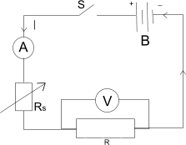

**Circuit components:**

|  |  |  |
| --- | --- | --- |
| **Components Name** | **Symbol** | **Purpose (use)** |
| Switch | +  – | Closes or opens the circuit |
| Cell |  | Source of e.m.f |
| **Components Name** | **Symbol** | **Purpose (use)** |
| Battery (group of cells) |  | Source of e.m.f |
| Standard Resistor | OR |  |
| Rheostat (Variable resistor) | OR | Contols amount of current flowing in the circuit |
| Ammeter | A | Measures the amount of current flowing through a circuit component |
| Voltmeter | V | Measures the p.d across a circuit component |
| Galvanometer | G  OR | Used to measure very small p.ds or currents in mV or mA respectively. |
| Lamp |  |  |

All the circuit components are connected by a system of electric wires of negligible resistance.

**POTENTIAL DIFFERENCE (p.d):**

*Potential difference (p.d) : Is the work done in moving a coulomb of charge from one point to another.*

***SI unit of potential difference*** is the Volt (V).

**Definition of a volt**.

*A Volt is the potential difference between two points in a circuit if 1 joule of work is done to move one coulomb of charge between the two points.*

**ELECTROMOTIVE FORCE (E.M.F)**

1. *Electromotive force* *is the potential difference across the terminals of cell in an open circuit.*

2. Electromotive force (e.m.f) *is the total work done in joules per coulomb of electricity conveyed in a circuit in which the cell is connected.*

3. Electromotive force *is the sum of all p.d’s across the different components of a circuit in which the cell is connected including the p.d required to drive current through the cell itself.*

**S.I unit of e.m.f** is the Volt (V).

**OHM’S LAW**

*Ohm’s law states* that:***the current flowing through a conductor is directly proportional to the potential difference across the ends of the conductor provided temperature and other physical conditions are kept constant.***

**V = IR** is the mathematical representation of ohm’s law.

Where, V = potential difference, I = Current, R = resistance.

NOTE:

V

I

R

**Question 1:**

Find the p.d across a conductor of resistance when 720 C passes through it in 4 minutes.

Answer:

Given:

Current:

p.d :

**Question 2:**

The p.d across a resistor was found to be 30 V. Find the amount of electric charge that passed through it for 45 minutes.

ANSWER:

Given:

Current:

Charge:

**EXPERIMENT**: **To verify ohm’s law**.



The circuit is set up as above.

The rheostat is set to a minimum value to let the maximum current pass through it.

The switch, S is closed and both the voltmeter and ammeter readings are noted and recorded.

The above procedure is repeated for various values of V and I.

The readings are recorded in the table as shown;

|  |  |
| --- | --- |
| I/A | V/v |
| -  -  - | -  -  - |

The results in the table are then used to plot a graph of V against I as shown;

V(V)

I(A)

V(V)

A straight-line graph through the origin verifies ohm’s law i.e. V I .

The resistance of the conductor is given by the slope of the graph.

*Slope of the graph =.*

**Classification of electric conductors**

There are two types of electric conductors namely;

1. ***Ohmic conductors***: these are conductors that obey Ohm’s law. Examples of *Ohmic conductors* include most metals like, copper, aluminium, silver e.t.c.
2. ***Non – Ohmic*** conductors; these are conductors that do not obey Ohm’s law. Examples of non – Ohmic conductors include (i) semi- conductors (ii) diodes (iii) electrolytes.

**Characteristic graph for Ohm’s law.**

*Ohmic conductors* _ Conductors that obey Ohm’s Law.

Graph of V against I

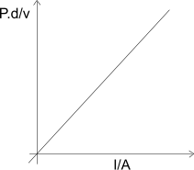

**Graphs of Non- ohmic conductor**: Conductors that do not obey Ohm’s law.

1. Dilute sulphuric acid (electrolyte)

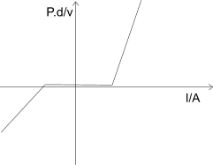

1. Thermionic diode

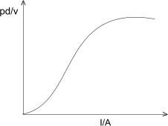

1. Semiconductor junction diode

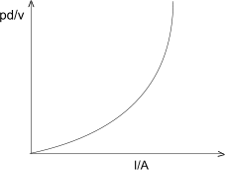

1. Neon gas

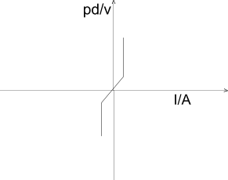

1. 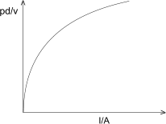Tungsten filament

**Conduction of electricity in metals:**

Metal conductors have free electrons that wander randomly from atom to atom.

When a source of e.m.f is connected across the ends of the metal conductor, an electric field develops. The free electrons experience a force due to the electric field which makes the drift from a region of low potential to that of high potential of the cell.

This movement of free electrons constitutes an electric current.

current

Metal conductor

**Conduction of electricity in liquids:**

Some liquids conduct electricity and others do not.

* An ***electrolyte*** is a solution that conducts electricity.
* Examples of electrolytes include,

1. dilute acids e.g dilute sulphuric acid, dilute hydrochloric acid.
2. Bases (alkalis) e.g sodium hydroxide, potassium hydroxide.
3. salts e.g sodium chloride, copper sulphate.

The set up below can be used to study the flow of electric current in a liquids and solutions.

+

-

+

-

cathode

anode

electrolyte

When an electric current passes through an electrolyte, a chemical reaction takes place at the surface of the electrodes. This process is known as ***electrolysis***.

Conduction of electricity during electrolysis is due to the movement of ions.

When the electrodes are connected to a source of e.m.f, an electric field causes the ions to move. ***The positive ions move towards the negative electrode (cathode) while the negative ions move towards the positive (anode).*** This is known as the ionic theory

This movement of ions in an electrolyte constitutes the electric current in an electrolyte.

**USES OF ELECTROLYSIS:**

Electrolysis is used in.

1. Refining copper.
2. Extraction of aluminium.
3. Electroplating.

**ELECTROPLATING**:

*Electroplating is the depositing of a thin layer of metal by the process of electrolysis*

The deposited metal is useful because of:

1. its pleasing appearance.
2. the protection it gives against rusting or corrosion.
3. its hardness.
4. making a worn-out piece of metal thicker (stronger).

**RESISTANCE AND RESISTORS**

***The Resistance*** of a substance*is* *the opposition of the substance to the flow of current* *through it*.

**S.I unit of resistance** is the *ohm* (Ω).

**Definition of an ohm**

*An Ohm is the resistance of the conductor which allows the current of one ampere to flow through it when the potential difference between the ends of the conductor is one volt.*

A *resistor* is a conductor which opposes the flow of current through it.

The two common types of resistors are categorized as:

1. Standard resistor: this is a resistor with a fixed resistance.
2. Variable resistor (rheostat): this is arrestor whose resistance can be changed or varied

**FACTS ABOUT RESISTORS**:

Resistors are used electrical appliances like; Electric heaters, radios, TV sets, Computers, projectors, e.t.c. in order to:

1. Limit or divide the current.
2. Reduce voltage
3. Protect an electric circuit, or
4. Provide large amounts of heat as in heaters or light in bulbs.

**Arrangement of Resistors**.

Resistors can be arranged either in series, or in parallel.

**Series connection of resistors.**

Consider three resistors of resistance R1, R2, R3 connected end to end as shown.

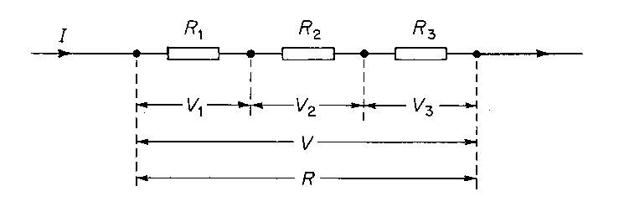

The same current, I , is passing through R1 ,R2 and R3.

Total potential difference across R1 ,R2 and R3  is

**V= V1 +V2 +V3** ………………………………………………………….(1).

from ohm’s law : **V = IR, V1 = IR1, V2 =IR2, V3 = IR3**.

There equation (1) becomes;

**IR = IR1 +IR2 +IR3**

**1R =I (R1+R2 +R3)**

**R = R1+ R2 +R3**

Note:

*The effective resistance in series is the sum of the individual resistances.*

*Effective resistance is larger than the largest resistance in the series connection.*

**Parallel connection of resistors:**

When resistors are connected in parallel as shown below:

* the potential difference, V across the resistors in parallel is the same.

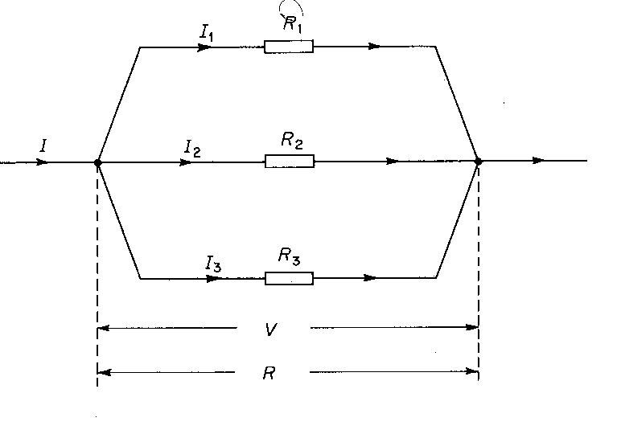

* Total current entering the junction is equal to sum of the individual currents leaving it.

From ohm’s law,

*Effective resistance is smaller than the smallest resistance in parallel.*

Note : For two resistance in parallel

**Therefore,**

**EXAMPLES:**

Determine the effective resistance in each of the circuits represented below.

1.

d3.png

ANS: Effective resistance R = R1+ R2 = 4+2 = 6Ω

2.

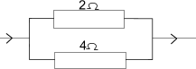

ANS: Effective resistance , .

3.

d5.png

Resistance in parallel , .

Effective resistance R = R3 +RP

R = 2 +1.33

R = 3.33 Ω

4.

2 Ω

**2 Ω**

**2 Ω**

**1 Ω**

**3 Ω**

**7 Ω**

Effective resistance in parallel

Effective resistance in the circuit:

FACTORS AFFECTING THE RESISTANCE OF THE CONDUCTOR.

1. **Length of the conductor**

The longer the conductor the higher the resistance. i.e. the resistance of a conductor is directly proportional to its length.

1. **Area of cross section of a conductor**

The greater the diameter, the lower the resistance i.e the thicker it is, the less the resistance. The resistance of a conductor is inversely proportional to its cross-sectional area.

1. **Temperature**

Increasing the temperature of a conductor increases its resistance.

1. **Nature of the conductor**

The higher the number of free electrons in a conductor, the lower its resistance to the flow of current through it.

Therefore, metals are better conductors of electric current.

**Resistivity of a conductor (**

Resistance of a conductor is directly proportional to its length and inversely proportional to its cross-sectional area.

Therefore, , where, a constant known as the resistivity of the conductor

Definition:

***Resistivity is the resistance of a conductor of unit length and unit cross-section area.***

**S.I unit of resistivity** is the Ohm metre .

**EXAMPLES:**

1. A wire 0.6 m long and diameter 0.2 mm has a resistance of 2.0 Ω. What is the resistivity of the material of which the wire is made of?

ANSWER:

1. The resistivity of copper is . Determine the resistance of a copper wire 49 m long and of diameter .

ANSWER:

Given

.

**APPLICATIONS OF RESISTANCE:**

1. A heating element is usually coiled so as to increase its length which in turn increases its resistance and area of contact with the substance it is heating.
2. Lamp filaments are made of coils of metal alloys that are of high resistance and are thin (small cross-sectional area). This enables them to develop very high temperature and light when current passes through them.
3. Long distance transmission cables are usually thick (large cross –sectional area) low resistance metals in order to reduce their resistance to flow of current through them. This in turn reduces heat that can be generated by large resistances.

**CALCULATIONS INVOLVING VOLTAGE/ OHM’S LAW:**

1. Consider a current of 3A passing through three resistors of resistance 4Ω, 2Ω and 3Ω as shown below.

4 Ω

2 Ω

3 Ω

Calculate the potential difference across each resistor.

p.d V1 = IR1 p.d V2 = I R2 p.d V3 = I R3

= = =

= 12 V = 6V = 9V

1. Calculate the total p.d across the following system of resistors when a current of 2.A passes through them.

2 Ω

3 Ω

3.8 Ω

2 A

Resistance in parallel

Effective resistance

The total p.d

**Terminal potential difference.**

***DEFINITION***

***Terminal p.d*** *is the p.d across the terminals of the cell when the cell is driving current in an external resistor .*

**OR**

*It is the p.d across the external resistor(s) in which the cell is connected.*

A p.d of 24 V is supplied to a network of resistors as shown below

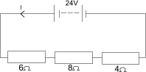

Calculate

1. The effective resistance
2. Total current through the circuit
3. p.d across the 8Ω resistor, 6 Ω resistor and 4 Ω resistor respectively
4. R = R1 +R2 +R3  (resistances in series)

= 18Ω

1. Current, I = (the same current passes through all the resistors in series)

1. V2 = IR2

=

= 10.67V

1. V1 = IR1

=

= 8.0V

1. V3 = IR3

=

= 5.33V

NOTE:

3. A battery of E.M.F 10 V and negligible internal resistance , is connected to external resistances of 2.4 Ω, 6Ω, 4 and 2.6

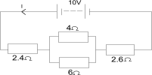

Calculate

1. the effective resistance in the circuit.
2. The p.d across the parallel connection of resistors.
3. The current through the two resistance in parallel.
4. Rp = R = Rp +R3 +R4

= = 2.4 + 2.4 +2.6

= = 7.4Ω is effective resistance in the circuit.

= 2.4Ω

ii) the p.d across the resistor in the parallel setting

Vp = IRp

But

(iii) current through 4 Ω and 6 Ω

p.d across the 4 Ω and 6 Ω is the same =

I1 =

=

= 0.54A

I2 = = = 0.81 A

NOTE:

1. A source of EMF 20V and negligible internal resistance is connected to resistance of 2Ω , 3Ω, and 2Ω as shown below

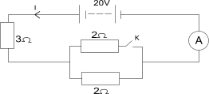

Find the ammeter reading when the switch is

1. Closed

Effective resistance in the circuit =

= 5A

current

1. When K is open, current flows through the lower 2Ω resistor but not in the upper 2Ω resistor which will be out of circuit

Effective resistance

Current,

Hence the ammeter readings are 5A and 4A when K is closed and open respectively

**INTERNAL RESISTANCE**.

***Internal resistance of a cell is the opposition to the flow of current with in the cell itself.***

Consider these circuits

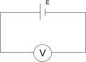 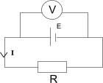

When the voltmeter is directly connected to the cell , it reads V =E , the e.m.f of the cell.

When the cell is connected to a standard resistor R, the voltmeter reading is V, the terminal p.d across the external resistance, R.

But V is less than E

* E is the *electromotive force* of the cell.
* V is the terminal p.d across resistor, R.
* A voltmeter can measure the terminal p.d. when it is connected in a closed circuit.

The p.d consumed within the cell equal is to E – V , commonly referred to as the “lost volts” , because they cannot be detected by the Voltmeter.

So internal resistance r =

Therefore ***E = V + Ir (i.e. e.m.f. = terminal p.d + p.d acrsss internal resistance of the cell)***

But V = 1R,

E = IR + 1r

***E = I (R+r)***

***This is known as the circuit equation.***

***Example 1.***

2 resistors each of 4 Ω are connected to a 2 V cell and an ammeter as shown below

a) Find the reading of the ammeter if the internal resistance of the cell is 1Ω

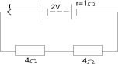

total external resistance R = R1 + R2

R = 4+ 4 = 8Ω

E = I (R+ r)

2 = I(8 +1)

, is the Ammeter reading.

***Example2***

A cell supplies a current of 0.6A through a 2Ω resistor coil and a current of 0.2 when connected to a 7 Ω resistor. Find

1. the internal resistance of the cell,
2. the e.m.f of the cell.

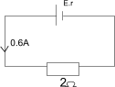 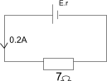

(ii)

1. A cell supplies a current of 2.4 A through two 2Ω resistors connected in parallel. When the resistors are connected in series, a current of 1.2 A is required. Calculate the E.MF and internal resistance of the cell.

E, r

1.2A

2Ω

2Ω

2Ω

2Ω

E, r

2.4A

Also

E =I ( +r) , E = I (+r)

E = 2.4(1+r ) …(i) E = 1.2 (4+r) …(ii)

Solving (i) and (ii) simultaneously

2.4(1 +r) = 1.2(4+ r)

2.4 +2.4r = 4.8 +1.2r

(2.4 – 1.2)r = 4.8 – 2.4

1.2r = 2.4

r = 2Ω

E.M.F E = 1.2(4+ r)

E = 1.2(4+2)

E = 1.2(6)

E = 7.2V

1. The figure below shows a 12V battery of internal resistance 0.6 Ω connected to 3 resistors A, B, and C. Find the current flowing in each resistor.

A=1Ω

B=4Ω

C=6Ω

E=12V, r=0.6Ω

Total resistance of circuit, R = 1 + ( + 0.6

R = 1 +2.4 +0.6 = 4Ω

Current supplied by battery, I = = = 3A , is also current flowing through resistor A.

p.d across parallel resistors B and C : Vp = IRP

Vp = 3A x 2.4Ω = 7.2V

Current through C : I2 = = = 1.2 A

Current through B: I1 = = A

**EXPERIMENT: To determine the internal resistance of a cell.**

V

E, r

**Procedure**

* Measure the e.m.f., E of the cell using a voltmeter

E, r

A

S

V

R

connected to the terminals in an open circuit.

* Connect the cell in series with switch S, a standard resistor R

and ammeter A. Connect the voltmeter V

across the terminals of the standard resistor R as shown

in the diagram.

* Close the switch S and read and record the ammeter and

Voltmeter readings I and V respectively.

* Calculate the internal resistance of the cell from the formula

**CONNECTING CELLS**

Cells may be connected in series or in parallel

1. **Series connection**.

In series connection, the positive terminal of one cell is connected to the negative terminal of the next cell.

So effective E.M. F is the sum of the individual E.M.F’s.

Effective em.f

Effective internal resistance,

1. **Parallel connection:**

In the parallel connection of cells, all the positive terminals of the cells are connected together as are their negative terminals as shown in the diagram below.

The effective e.m.f. is equal to the e.m.f. of one cell

i.e.

Effective internal resistance is the sum of the reciprocal of the internal resistance

i.e.  **=**

NOTE: If cells are to be connected in series, they must be identical i.e. of the same e.m.f and internal resistance.

If one of the cells has a larger e.m.f than the others, it will drive current through the weaker cells, even when the circuit in which the cells are connected is open. This will result into the cells getting drained.

Therefore, cells should never left in parallel connection when not in use.

Examples:

1. Two identical cells of emf 1.5V and internal resistance 0.2 Ω are connected
2. In series b) in parallel

Find the current in each case when the cells are connected to the 1Ω resistor.

ANSWER:

A

E , r

I

A

E , r

(a)

Effective emf,

Effective internal resistance,

External resistance,

Circuit equation,

Current,

A

I

E,r

E,r

(b)

I

A

Effective emf,

Effective internal resistance,

External resistance,

Circuit equation,

Current,

1. 6 cells each of 2 V and internal resistance 0.1Ω are connected in series with an ammeter besides them of negligible resistance. A resistor R = 1.4 Ω and a metal filament lamp are connected in series with the cell. The Ammeter reading is 3A. calculate



1. resistance of the lamp
2. p.d. across the lamp

ANSWER:

Resultant e.m.f

Resultant internal resistance,

Ammeter reading,

Resistance of the lamp.

Resistance of the standard resistance.

Circuit equation,

(b) p.d across the lamp,

1. a) Define the terms
2. electromotive force
3. the volt

a battery of emf 12 V and negligible internal resistance is connected to resistances 2Ω, 3Ω, 6Ω as shown above. Find the currents I1 and I2 .

ANSWER:

Effective resistance

Current entering a junction = current leaving the junction

Also

Substituting for in (1)

**AMMETERS, VOLTMETERS AND GALVANOMETERS**

**1. GALVANOMETER**

A galvanometer is an instrument used to measure very small currents or voltages.

A galvanometer that measures current in milliamperes (mA) is called a ***milliammeter***.

The current that deflects the pointer from zero to the extreme end of the scale is called the ***full scale deflection current*** (***fsd***).

mA

**2. AMMETER**

An ***Ammeter*** is a low resistance electrical device used to measure the current flowing through an electric component connected in an electric circuit.

**CONVERSION OF GALVANOMETER INTO AMMETER.**

* An ammeter ***is always placed in******series*** with a resistor in a circuit or other circuit components through which the current is to be measured. (An ammeter measures larger current than the galvanometer)
* An ammeter therefore should have ***very low resistance*** as compared to the rest of the circuit so that it does not produce unwanted resistance. This also ensures that the ammeter does not alter the current it is supposed to measure.

The method of converting a galvanometer to an Ammeter involves ***connecting a low- resistance resistor Rs, called a shunt, in parallel*** with the resistance of galvanometer.

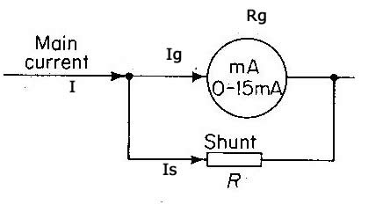

**I** = current to be measured

**Rg** = resistance of galvanometer

**Rs**= Shunt resistance

**Ig** = maximum current through the galvanometer = full scale deflection (f.s.d).

**Is** = current through the shunt **Rs.**

Since the galvanometer resistance and the shunt are in parallel connection, then

1. **.**
2. **p.d across the galvanometer resistance = p.d across the shunt.**

**applying ohm’s law .**

**Example 1.**

A galvanometer has a resistance of 20 Ω and gives a f.s.d of 200 mA.

Find

1. the voltage a cross the galvanometer.
2. the resistance (shunt) that must be connected across the galvanometer for it to read 10 A.

ANSWER:

1. Voltage a cross galvanometer ,
2. Current through the shunt , **.**

**p.d across the galvanometer resistance = p.d across the shunt.**

**.**

**Example 2.**

A galvanometer of resistance 10 Ω reads 50 mA at f.s.d. what resistance must be connected across the galvanometer to convert it to an ammeter that will read 4A.

ANSWER:

Current through the shunt , **.**

**p.d across the galvanometer resistance = p.d across the shunt.**

**.**

**3. VOLTMETER.**

* A ***Voltmeter*** is a high resistance electrical device used to measure the potential difference (p.d) across an electric component in an electric circuit.
* The Voltmeter ***is always connected in parallel*** with the electric component whose p.d it is to measure.
* The voltmeter must always be of ***very high resistance*** so that it draws as little current as possible from the circuit in which it is connected.

**CONVERSION OF GALVANOMETER TO VOLTMETER:**

This is done by ***connecting a resistor of high resistance in series*** with the galvanometer. This resistor is called a **multiplier**. (This enables the galvanometer to measure larger p.d.)

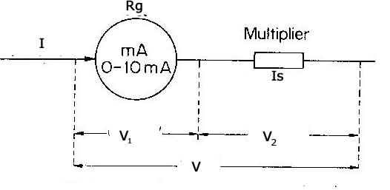

Suppose that a full-scale deflection

= maximum current through G.

V = p.d across the voltmeter.

= p.d a cross galvanometer.

= p.d across multiplier

Since the galvanometer resistance and the Multiplier are in series; then

1. **.**

**.**

**EXAMPLES:**

1. A galvanometer of resistance 12 Ω reads 200 mA at f.s.d . What resistance must be connected in series with it in order to read 8 V.

ANSWER:

.

.

1. A current of 0.2 A passes through the galvanometer of resistance 20 Ω. What resistance must be connected in series with galvanometer to convert it to voltmeter that reads 10 V at f.s.d.

ANSWER:

.

.

**ELECTRICAL POWER AND ENERGY.**

If Q is the Quantity of electricity (charge) flowing when a p.d., V is applied to ends of a conductor, the electrical work done is equal to product of the p.d, V and the charge, Q.

Work done

**W = V Q** . …………………………………….(1

But Charge, Q = current time i.e. ,

therefore

Electrical heat = work , **W = V I t** ………………………… (2

but V = IR , according to Ohm’s law

…………………………………………………………(3

also **I =**  , therefore

**…………………………………………………………….**(4

Electrical energy = electrical work done,

* S.I unit of electrical work is a **Joule** (J).

**ELECTRICAL POWER**

Is the rate at which heat is generated in the conductor when current flows through it

Electrical power =

**P = = VI = I2R = .**

* S.I unit of work is the **Watt (W)** .
* 1 watt = 1 .

***A watt is the rate of working of 1 Joule per second.***

Other units of power include;

- kilowatt (kW)

- megawatt (MW)

(1kW= 1000W and 1 MW = 1000kW = 1,000,000W)

**Examples.**

1. A current of 2 A passes through a resistor of 3Ω. Calculate the
2. p.d across the resistor.

(ii) the power used by the resistor.

1. A lamp is rated 240 V, 60 W

a) what does that statement mean?

b) Find,

i) current consumed by the lamp

ii) resistance of the filament

1. A battery of e.m.f. 24V is connected in series with a resistor R and a lamp rated 10 V , 20 W as shown below .

Diag

24 V

R Ω

Bulb

If the bulb is operating normally, find

1. The p.d across the resistor
2. The value of R
3. The power dissipated in the resistor

**COMMERCIAL ENERGY COSTS (COST CALCULATIONS)**

Electricity boards charge for electric energy they supply. The boards trade unit of electrical energy is called ***kilowatt hour (kWh)*** .

* ***A kilo watt hour is the electrical energy used by a rate of working of 1 kW appliance in 1 hour.***

**MARKING AN ELECTRIC APPLIANCE**

All electrical appliances are marked showing the ***power rating*** in watts and the ***voltage*** in volts.

If an appliance is marked as , it means that: ***the appliance supplies or consumes 60 W of electrical energy per second when connected to 240 V.***

**Example**

1. Find the cost of running five 60 W and four 100 W lamps for 8 hours if electrical energy cost shs.5 per unit

**ANSWER**

Total power consumed

Electrical cost

1. A house has one 100 W bulb, two 75 W bulbs and five 40 W bulbs . Find the cost of having all lamps switched on for two hours every day for 30 days at a cost of per unit.

ANSWER:

Total power consumed .

Total time,

Electrical cost

QUESTIONS

1. Calculate the cost of running an electric fire alarm for 2½ hours if it takes 13 A on 100 V supply and each unit costs
2. A 2 kW electric fire alarm is used for 10 hours each week , a 100 W bulb is used for 10 hours each day find the total cost for each week if a unit of electricity cost shs. 300.
3. A house contains three 60 W lamps and two 100 W lamps which are switched on for 8 hours if one unit of electricity costs 250 , how much money should be paid ?
4. A 2 kW heater is used for 10 hours and a 100 W lamp is used for 8 hours each day find the total cost paid for electricity at the end of the month if each unit costs shs.100 and the month is assumed to have four weeks.
5. An electric heater is immersed in 0.05 kg of oil in a calorimeter of negligible heat capacity . The temperature of oil rose from 20oC to 50oC in 100 seconds. If the specific heat capacity of oil is . calculate
6. Power supplied by the heater
7. The cost of running the heater for 100 s each day for 8 days if each unit costs shs.400.
8. State any assumptions made .

**HOUSE CIRCUIT : DOMESTIC INSTALLATION**

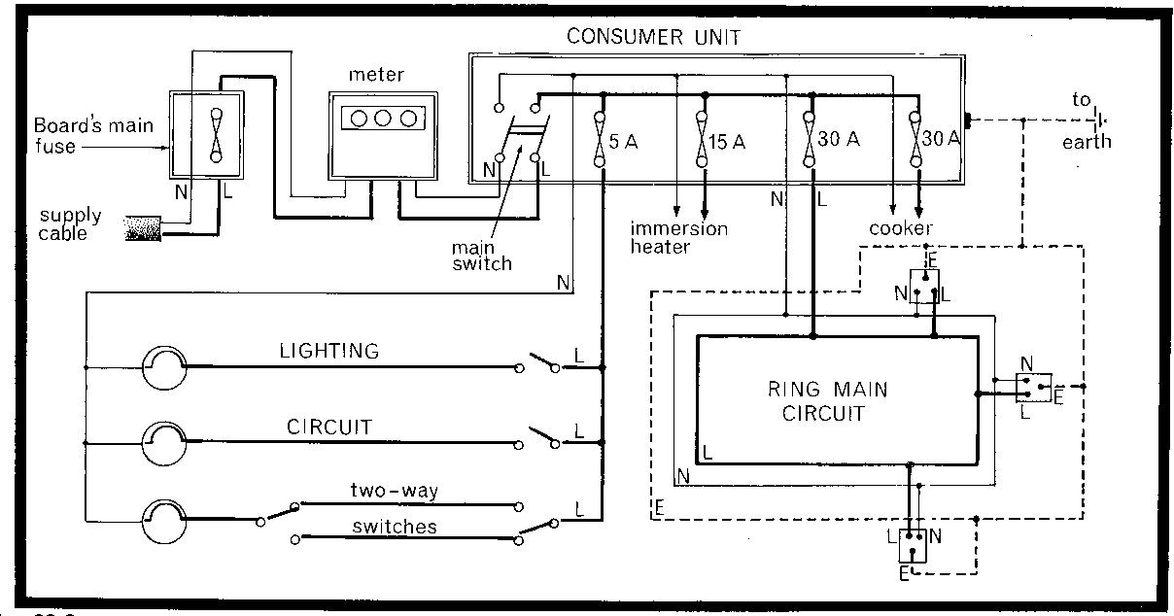

THE SUPPLY CABLE

* Electricity enters the house through the ***supply cable*** from the pole.
* The supply cable consists of two insulated wires, the **live** and the **neutral** wire.
* The neutral is earthed at the local substation and is therefore at zero potential while the live wire is at a potential of 240 V .
* The *live wire* (**L**) is either **red** or **brown** while the *neutral (***N***)* is **black** or **blue** .
* The live wire delivers current from the local sub-station or power supply to the respective appliances while the neutral carries it back to the power supply, thus completing the circuit.

NOTE: All **switches** and **fuses** are connected to the *live wire*.

THE MAIN FUSE AND METER

* Each of the two wires (live and neutral) is connected to the **meter** through the **main fuse box** .
* A thick copper wire is connected from the meter to the earth and it is therefore at zero potential. It protects the meter and the house against damage in case of overloading or short circuit.

CONSUMER UNIT

* From the meter the cables are passed to the consumer unit which contains the main switch to switch off all current in the house
* The main switch is a double hole switch which breaks both the live and the neutral.
* The consumer unit also contains single pole fuses for each of the following circuits

1. Lighting circuit connected to 5A fuse.
2. Immersion heater circuit controlled by 15A fuse.
3. The ring main circuit is controlled by 30 A fuse.
4. Cooker controlled by a 30 A fuse.

***Every circuit is connected in parallel with the power supply***, i.e. across the live and the neutral wires. There is no connection between the live the neutral wires except through an electrical appliance.

The parallel connection ensures that.

* 1. A fault in one circuit does not affect the other circuits.
  2. All appliances operate at the same supply voltage of 240 V, but use different amounts of current.
  3. The appliances in the different circuits operate independently of each other.

i.e. they could be working all at the same time or one is working while the other is switched off.

In wiring the lighting circuits only two wires are required but for ring circuits, the heater and the cooker, the earth wire must be introduced. This is because the lighting circuit uses currents that are very low, while the heater and cooker use rather large currents.

**Earthing** prevents electric shocks.

HOW THE EARTH CONNECTION PREVENTS ELECTRIC SHOCKS:

* The earth wire connects the metal case of an appliance to the ground.
* If the insulation of the live wire wears out such that stands of the live wire come into

contact with the metal casing of the appliance, the earth wire will carry away the current to the earth. The fuse in the live wire will blow and cut off the current

Earth wire

Neutral wire

Live wire

Metal case

Fuse wire

ground

**THE RING MAIN CIRCUIT**

This is a circuit which runs in complete rings round the house. It provides parallel circuit connections to each electrical appliance plugged into the sockets.

Since the currents drawn from the ring main circuit are large, the ring main circuit incorporates an earth connection and 30A fuse.

SAFETY DEVICES

1. **The fuse**

It melts and breaks the circuit in case of overloading or short circuit.

1. **The earth wire.**

The earth wire prevents electric shocks in case short circuits occur.

1. **Switches:**

Switches are connected to the live wire to break and complete the circuit.

1. **Circuit breaker**

This is used to disconnect the mains current when there is an accidental earthing of the live wire.

**Safety precautions**

1. Electric cables must be properly insulated.
2. Keep hands dry whenever dealing with electrical appliances.
3. Never try to repair an electric appliance unless you are trained.
4. Wear dry rubber glove and shoes when handling electrical appliances.
5. Fix sockets at a height beyond the reach of children.
6. Keep proper plug in the circuit
7. In case one gets a shock switch off the main switch immediately.
8. Electrical switches or sockets are not fixed in the bath rooms in house wiring.

**ELECTRICAL DEVICES**

**1. The three-pin plug: and Socket.**

The 3 – pin plug has three pins that are marked with letters L, N and E standing for *live*, *neutral* and *earth* respectively.

The earth pin is slightly longer than the other two, and the live pin is on the right-hand side when the plug is fixed into the socket.

WIRING A THREE PIN PLUG

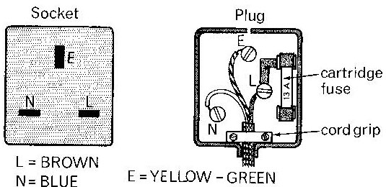

* The fuse in the plug is connected to the live wire in the circuit.
* The earth wire from the three pin plug is connected to a casing of the appliances so that in the event of a short circuit the person handling the faulty appliance does not get an electric shock.

**APPLICATION OF ELECTRICAL HEATING**

It is used in electrical appliances like

1. Electric bulbs and tubes.
2. Electric flat iron.
3. Electric kettles.
4. Cookers e.t.c
   1. **FILAMENT LAMP:**

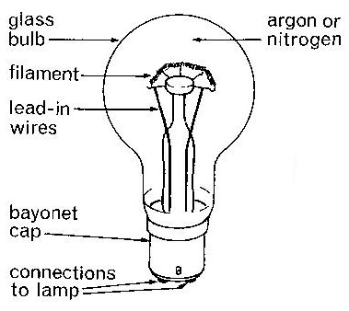

* It consists of the filament made of a thin and coifed *tungsten wire*.
* When a current passes through such a filament, it heats up so much such that it becomes quite hot and it emits light.
* The filament bulb is filled with an inert gas e.g nitrogen or argon at reduced pressure.
* The gas prevents evaporation of tungsten and increases its operating temperature otherwise it condenses or blackens.

NOTE:

* The efficiency of the bulb is improved by using a coiled filament which reduces the space occupied by the filament and also reduces the rate of heat loss by convection.
* Tungsten is used because it has a high meting point (3650 K)

LIMITATIONS OF TE FILAMENT LAMP:

* 1. They are inefficient since most f the electrical energy is converted to heat energy.
  2. They are uneconomical to use.
  3. They do not last for long.

**2**. **FLOURESCENT TUBES**

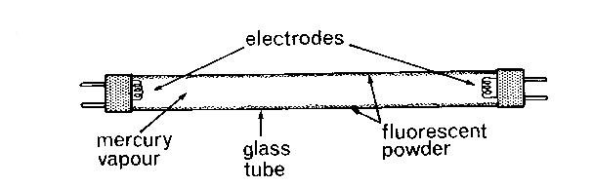

A Fluorescent tube is a glass tube filed with mercury vapour.

The inside of the glass tube is coated with a fluorescent material.

It has electrodes fixed at both ends inside with leads to be connected to the mains.

**How it works**

When the tube is switched on, the filament becomes white hot and emits electrons.

The electrons are attracted to the anode.

As the electrons flow, they collide with mercury atoms and the excited mercury atoms produce short wave length ultra-violent radiations.

The radiations strike the fluorescent powder causing it to glow and it emits light, the colour of which depends on the colour of the powder.

ADVANTAGES OF FLOURESCENT TUBES OVER FILAMENT LAMPS

* + 1. They do not produce unnecessary heat.
    2. They are more economical to use i.e. they consume less electrical energy.
    3. They are more long lasting (durable).

**3**. **ENERGY SAVERS**

Energy savers use the same principle as fluorescent tubes.

However, they differ in shape and size.

They save energy in that most of the electrical energy is converted to light.

**4. DISCHARGE LAMPS.**

Discharge lamps operate in the same way as fluorescent tubes. However, they do not have a fluorescent material, instead they emit light characteristics of the gas or vapour inside the tube.

Discharge lamps are commonly used in advertisement signs and decorations.

**Electric flat iron and kettle**

Heating appliance contains a heating element often made of nichrome wire which is an alloy of nickel and chromium. Nichrome wire is used because it does not oxidize when it becomes red hot.

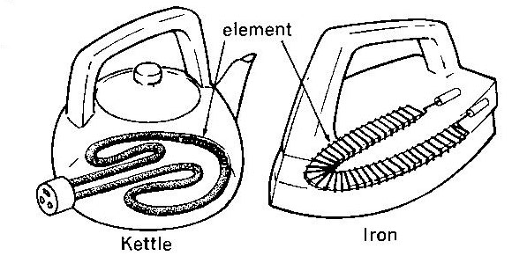

**FUSES**

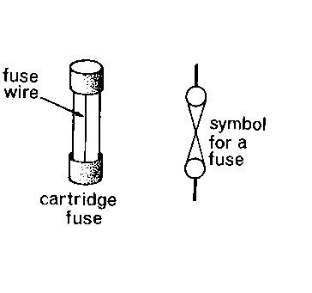

***A fuse is a short length of a thin wire of low melting point which breaks the circuit when the current through it exceeds a safe value.***

It is a protective resistor which melts when there is excessive current flow.

**How a fuse works:**

A fuse is of a value just higher than the normal current required by the appliance it is to protect.

If the current exceeds its rated value, the fuse wire will melt and the fuse “blows”.

The melted or “blown” fuse stops the current and protects the appliance against the risk of fire caused by the heat.

**A fuse is always connected to the live wire**.

**FUSE RATING**:

Fuses a rated at 2A, 5A, 13 A, e.t.c.

EXAMPLE:

If the power rating of an appliance is “ 2000 W, 240 V”

The required current is

The suitable fuse is 10 A.

**SHORT CIRCUIT**:

***A short circuit is a path of least resistance***.

Current tends to flow through a path of least resistance.

Short circuits usually occur when the live wire gets directly in contact with the neutral wire.

This causes a large current to flow between the live wire and the neutral wire, since they are both of very low resistance.

The large currents resulting from short circuits tend to cause overheating, sparking and even fires.

**ELECTRIC CONNECTIONS:**

There are two ways in which electric connections can be performed;

1. Series connection
2. Parallel connection.

**1. Series Connection.**

When electric components and appliances are connected in series

1. The same current will flow through all the components/appliances.
2. Each component/appliance will have its own p.d across its terminals depending on its resistance.

I

I

**Disadvantages of series connection:**

1. If one of the appliances is faulty or switched off, all the other appliances in the circuit will go off.
2. The series connection would require a very large voltage to supply them.

NOTE: in electrical wiring, all appliances connected in series use the same switch and the same fuse.

**2. Parallel connection:**

When electrical components/appliances are connected in parallel:

1. A different current will flow in each component/appliance depending on its resistance.
2. the same potential difference will be across all the terminals of components/appliances in the circuit.

**Advantages of parallel connection:**

1. If one of the appliances is faulty or switched off, the other appliances in the circuit remain unaffected.
2. Different currents flow through each of the components/appliances in the parallel connection.
3. All the appliances/components operate with the same potential difference.

NOTE: in electrical wiring, each appliance connected in parallel its own switch and fuse.

The switch and fuse are always connected to the live wire.

fuse 1

fuse 2

fuse 3

fuse 4

lamp1

lamp 2

lamp 3

lamp 4

Live

Neutral

240 V

supply